Triangle Takeaway

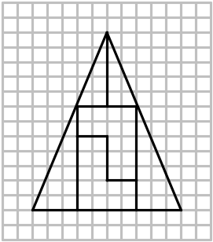

Task One

Copy this diagram onto 1cm squared paper.
What is the base of the triangle? What is the height of the triangle? Use these to find the area of the triangle. Write all the measurements in your books.

Task Two

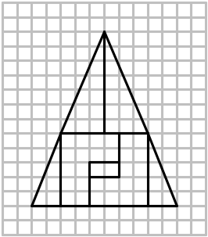Now colour in the back of the diagram. Cut out the four individual triangles and the two L-shapes. Turn the pieces over so that the coloured side faces up. Arrange the shapes as shown on the right. What is the base? What is the height? What is the area this time? Remember that two squares are missing.

Why does this seem unusual?

Task Three

Arrange your six pieces so that they form an L-shape with an area of 59cm².
This shape was discovered by Paul Curry in the 1960s and is known as the ‘Curry Triangle’.
Why do the same six pieces make three shapes with different areas? Can you work out how it is done?
Try to construct a trick shape of your own.
Triangle Takeaway

Task One

Copy this diagram onto 1cm squared paper.
What is the base of the triangle? What is the height of the triangle? Use these to find the area of the triangle. Write all the measurements in your books.

Task Two
Now colour in the back of the diagram.
Cut out the four individual triangles and the two L-shapes. Turn the pieces over so that the coloured side faces up. Arrange the shapes as shown on the right. What is the base? What is the height? What is the area this time? Remember that two squares are missing.

Why does this seem unusual?

Task Three

Arrange your six pieces so that they form an L-shape with an area of 59cm².
This shape was discovered by Paul Curry in the 1960s and is known as the ‘Curry Triangle’.
Why do the same six pieces make three shapes with different areas? Can you work out how it is done?
Try to construct a trick shape of your own.

